**RESULTS:**

|  |  |  |
| --- | --- | --- |
| **ORIGINAL IMAGE** | **PREPROCESSING** | **WATERSHED ROI** |
|  |  |  |
| **KMEANS ROI** | **ROI BY DETECTING EDGES** | **ROI BY DILATON AND EROSION** |
|  |  |  |

|  |  |  |
| --- | --- | --- |
| **ORIGINAL IMAGE** | **MASKED IMAGE (GROUND TRUTH)** | **SUPERIMPOSED IMAGE**  **WITH WATERSHED ROI** |
|  |  |  |
| **SUPERIMPOSED IMAGE WITH KMEANS ROI** | **SUPERIMPOSED IMAGE WITH ROI BY DETECTING EDGES** | **SUPERIMPOSED IMAGE WITH ROI BY DILATON AND EROSION** |
|  |  |  |

|  |  |  |
| --- | --- | --- |
| **2D PLOT** | **OVERLAP RATIO** |  |
| |  |  |  | | --- | --- | --- | | **MASK PLOT** | **WATERSHED PLOT** | **K-MEAN PLOT** | | [555, 230, 395, 478 ] | [682, 356, 172, 224] | [659, 320, 220, 302] | | **SOBEL OPE. PLOT** | **MORPHOLOGICAL OPE. PLOT** |  | | [652, 290, 216, 298] | [603, 320, 317, 287] |  | | |  |  |  |  | | --- | --- | --- | --- | | **WATERSHED** | **K-MEANS** | **SOBEL OPERATOR** | **MORPHOLOGICAL OPERATION** | | 0.2041 | 0.3519 | 0.3409 | 0.4819 | |  |
| **DICE INDEX** | **SSIM** |  |
| |  |  |  |  | | --- | --- | --- | --- | | **WATERSHED** | **K-MEANS** | **SOBEL OPERATOR** | **MORPHOLOG**  -**ICAL**  **OPERATOR** | | 0.1731 | 0.1734 | 0.4426 | 0.5429 | | |  |  |  |  | | --- | --- | --- | --- | | **WATERSH**  **ED** | **K-MEANS** | **SOBEL OPERATOR** | **MORPHOLOGI**  -**CAL**  **OPERATION** | | 0.3559 | 0.5521 | 0.5997 | 0.5423 | |  |

**GRAPH:**



|  |  |  |
| --- | --- | --- |
| **ORIGINAL IMAGE** | **PREPROCESSING** | **WATERSHED ROI** |
|  |  |  |
| **KMEANS ROI** | **ROI BY DETECTING EDGES** | **ROI BY DILATON AND EROSION** |
|  |  |  |

|  |  |  |
| --- | --- | --- |
| **ORIGINAL IMAGE** | **MASKED IMAGE (GROUND TRUTH)** | **SUPERIMPOSED IMAGE**  **WITH WATERSHED ROI** |
|  |  |  |
| **SUPERIMPOSED IMAGE WITH KMEANS ROI** | **SUPERIMPOSED IMAGE WITH ROI BY DETECTING EDGES** | **SUPERIMPOSED IMAGE WITH ROI BY DILATON AND EROSION** |
|  |  |  |

|  |  |
| --- | --- |
| **2D PLOT** | **OVERLAP RATIO** |
| |  |  |  | | --- | --- | --- | | **MASK PLOT** | **WATERSHED PLOT** | **K-MEAN PLOT** | | [247, 363, 409, 206] | [379, 402, 221, 142] | [188, 343, 522, 389] | | **SOBEL OPE. PLOT** | **MORPHOLOGICAL OPE. PLOT** |  | | [276, 348, 439, 226] | [306, 384, 338, 152] |  | | |  |  |  |  | | --- | --- | --- | --- | | **WATERSHED** | **K-MEANS** | **SOBEL OPERATOR** | **MORPHOLOGICAL OPERATION** | | 0.3725 | 0.4149 | 0.7442 | 0.6098 | |
| **DICE INDEX** | **SSIM** |
| |  |  |  |  | | --- | --- | --- | --- | | **WATERSHED** | **K-MEANS** | **SOBEL OPERATOR** | **MORPHOLOG**  -**ICAL**  **OPERATOR** | | 0.1141 | 0.1151 | 0.5693 | 0.6384 | | |  |  |  |  | | --- | --- | --- | --- | | **WATERSH**  **ED** | **K-MEANS** | **SOBEL OPERATOR** | **MORPHOLOGI**  -**CAL**  **OPERATION** | | 0.2134 | 0.5838 | 0.9719 | 0.8017 | |

**GRAPH:** 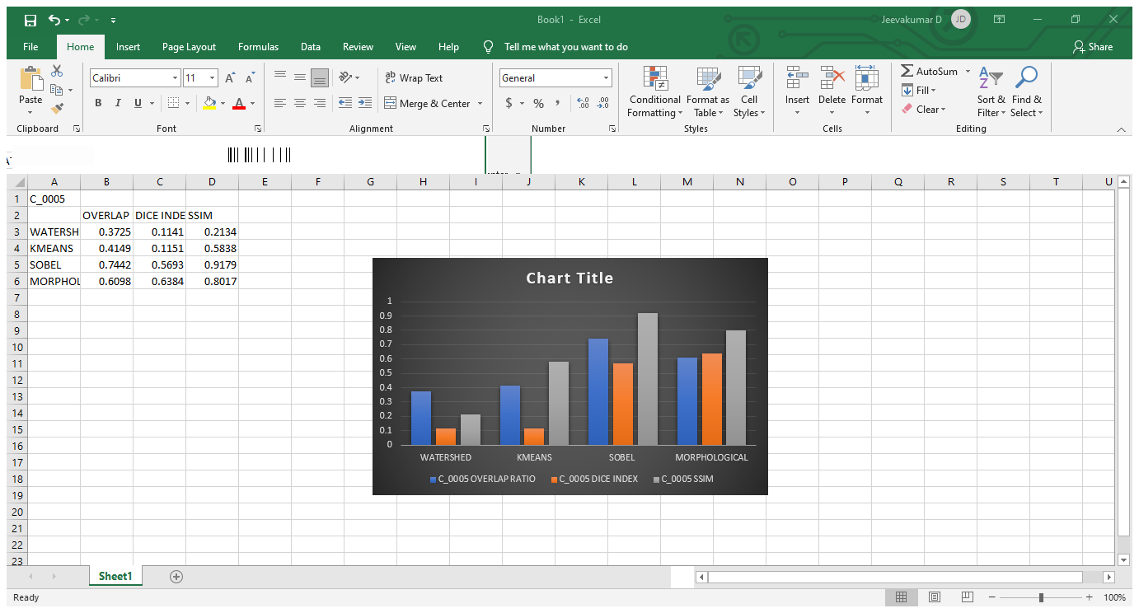

|  |  |  |
| --- | --- | --- |
| **ORIGINAL IMAGE** | **PREPROCESSING** | **WATERSHED ROI** |
|  |  |  |
| **KMEANS ROI** | **ROI BY DETECTING EDGES** | **ROI BY DILATON AND EROSION** |
|  |  |  |

|  |  |  |
| --- | --- | --- |
| **ORIGINAL IMAGE** | **MASKED IMAGE (GROUND TRUTH)** | **SUPERIMPOSED IMAGE**  **WITH WATERSHED ROI** |
|  |  |  |
| **SUPERIMPOSED IMAGE WITH KMEANS ROI** | **SUPERIMPOSED IMAGE WITH ROI BY DETECTING EDGES** | **SUPERIMPOSED IMAGE WITH ROI BY DILATON AND EROSION** |
|  |  |  |

|  |  |
| --- | --- |
| **2D PLOT** | **OVERLAP RATIO** |
| |  |  |  | | --- | --- | --- | | **MASK PLOT** | **WATERSHED PLOT** | **K-MEAN PLOT** | | [825, 164, 123, 77] | [594, 166, 381, 102] | [808, 164, 133, 80] | | **SOBEL OPE. PLOT** | **MORPHOLOGICAL OPE. PLOT** |  | | [815, 164, 115, 80] | [839, 167, 112,  77] |  | | |  |  |  |  | | --- | --- | --- | --- | | **WATERSHED** | **K-MEANS** | **SOBEL OPERATOR** | **MORPHOLOGICAL OPERATION** | | 0.2359 | 0.7990 | 0.7637 | 0.8043 | |
| **DICE INDEX** | **SSIM** |
| |  |  |  |  | | --- | --- | --- | --- | | **WATERSHED** | **K-MEANS** | **SOBEL OPERATOR** | **MORPHOLOG**  -**ICAL**  **OPERATOR** | | 0.0655 | 0.0631 | 0.6031 | 0.7448 | | |  |  |  |  | | --- | --- | --- | --- | | **WATERSH**  **ED** | **K-MEANS** | **SOBEL OPERATOR** | **MORPHOLOGI**  -**CAL**  **OPERATION** | | 0.7404 | 0.9993 | 0.9997 | 0.9995 | |

**GRAPH:**

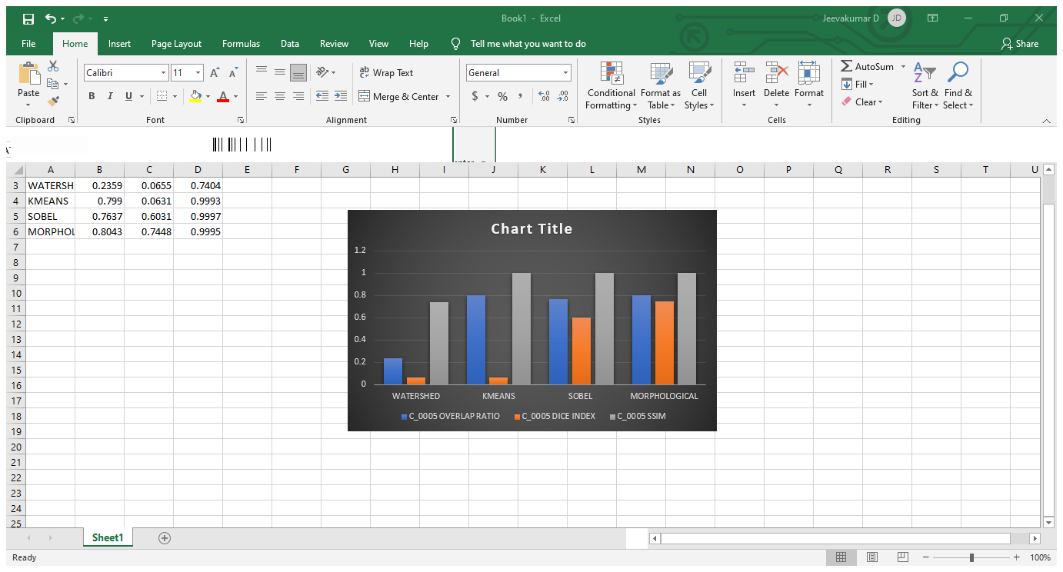

|  |  |  |
| --- | --- | --- |
| **ORIGINAL IMAGE** | **PREPROCESSING** | **WATERSHED ROI** |
|  |  |  |
| **KMEANS ROI** | **ROI BY DETECTING EDGES** | **ROI BY DILATON AND EROSION** |
|  |  |  |

|  |  |  |
| --- | --- | --- |
| **ORIGINAL IMAGE** | **MASKED IMAGE (GROUND TRUTH)** | **SUPERIMPOSED IMAGE**  **WITH WATERSHED ROI** |
|  |  |  |
| **SUPERIMPOSED IMAGE WITH KMEANS ROI** | **SUPERIMPOSED IMAGE WITH ROI BY DETECTING EDGES** | **SUPERIMPOSED IMAGE WITH ROI BY DILATON AND EROSION** |
|  |  |  |

|  |  |
| --- | --- |
| **2D PLOT** | **OVERLAP RATIO** |
| |  |  |  | | --- | --- | --- | | **MASK PLOT** | **WATERSHED PLOT** | **K-MEAN PLOT** | | [215, 356, 412, 209] | [403, 426, 204, 107] | [378, 436, 213, 108] | | **SOBEL OPE. PLOT** | **MORPHOLOGICAL OPE. PLOT** |  | | [352, 410, 275, 140] | [352, 399, 365,   199] |  | | |  |  |  |  | | --- | --- | --- | --- | | **WATERSHED** | **K-MEANS** | **SOBEL OPERATOR** | **MORPHOLOGICAL OPERATION** | | 0.2535 | 0.2672 | 0.4471 | 0.4037 | |
| **DICE INDEX** | **SSIM** |
| |  |  |  |  | | --- | --- | --- | --- | | **WATERSHED** | **K-MEANS** | **SOBEL OPERATOR** | **MORPHOLOG**  -**ICAL**  **OPERATOR** | | 0.1173 | 0.1181 | 0.5016 | 0.6149 | | |  |  |  |  | | --- | --- | --- | --- | | **WATERSH**  **ED** | **K-MEANS** | **SOBEL OPERATOR** | **MORPHOLOGI**  -**CAL**  **OPERATION** | | 0.0996 | 0.1863 | 0.3870 | 0.6435 | |

**GRAPH:**

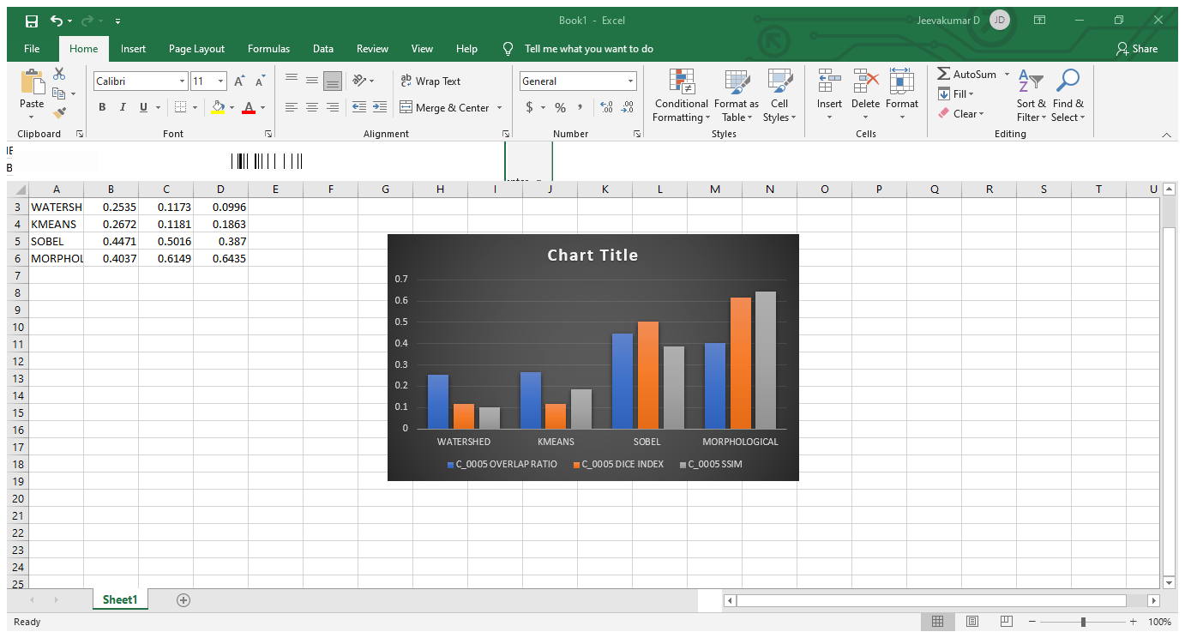

|  |  |  |
| --- | --- | --- |
| **ORIGINAL IMAGE** | **PREPROCESSING** | **WATERSHED ROI** |
| **B_3412** |  |  |
| **KMEANS ROI** | **ROI BY DETECTING EDGES** | **ROI BY DILATON AND EROSION** |
|  |  |  |

|  |  |  |
| --- | --- | --- |
| **ORIGINAL IMAGE** | **MASKED IMAGE (GROUND TRUTH)** | **SUPERIMPOSED IMAGE**  **WITH WATERSHED ROI** |
|  |  |  |
| **SUPERIMPOSED IMAGE WITH KMEANS ROI** | **SUPERIMPOSED IMAGE WITH ROI BY DETECTING EDGES** | **SUPERIMPOSED IMAGE WITH ROI BY DILATON AND EROSION** |
|  |  |  |

|  |  |
| --- | --- |
| **2D PLOT** | **OVERLAP RATIO** |
| |  |  |  | | --- | --- | --- | | **MASK PLOT** | **WATERSHED PLOT** | **K-MEAN PLOT** | | [39, 508, 288, 147] | [87, 533, 213, 102] | [22, 518, 308, 158] | | **SOBEL OPE. PLOT** | **MORPHOLOGICAL OPE. PLOT** |  | | [39, 518, 309, 179] | [43, 515, 315, 150] |  | | |  |  |  |  | | --- | --- | --- | --- | | **WATERSHED** | **K-MEANS** | **SOBEL OPERATOR** | **MORPHOLOGICAL OPERATION** | | 0.5132 | 0.7655 | 0.6780 | 0.7980 | |
| **DICE INDEX** | **SSIM** |
| |  |  |  |  | | --- | --- | --- | --- | | **WATERSHED** | **K-MEANS** | **SOBEL OPERATOR** | **MORPHOLOG**  -**ICAL**  **OPERATOR** | | 0.0781 | 0.0787 | 0.5692 | 0.6388 | | |  |  |  |  | | --- | --- | --- | --- | | **WATERSH**  **ED** | **K-MEANS** | **SOBEL OPERATOR** | **MORPHOLOGI**  -**CAL**  **OPERATION** | | 0.9581 | 0.9968 | 0.9950 | 0.9975 | |

**GRAPH:**



**INERENCE:**

The above process was done for over 100 images and the average values are

|  |  |  |  |  |
| --- | --- | --- | --- | --- |
|  | WATERSHED | KMEANS | SOBEL OPERATOR | MORPHOLOGICAL OPERATION |
| OVERLAP RATIO | 0.3252 | 0.5245 | 0.5984 | 0.6215 |
| DICE INDEX | 0.1087 | 0.1095 | 0.5463 | 0.6521 |
| SSIM | 0.7211 | 0.6646 | 0.7506 | 0.7960 |

* So the above table states that the overlap ratio, dice index and SSIM are high for ROI extraction by morphological operators(ie. Dilation and erosion).  The morphological concepts constitues a powerful set of tools for extracting regions of interest in an image. A significant advantage in terms of implementation is the fact that **dilation and erosion** are the primitive methods.
* The overlap ratio of the roi with morphological operators can be increased by integrating them with the thresholding techniques.

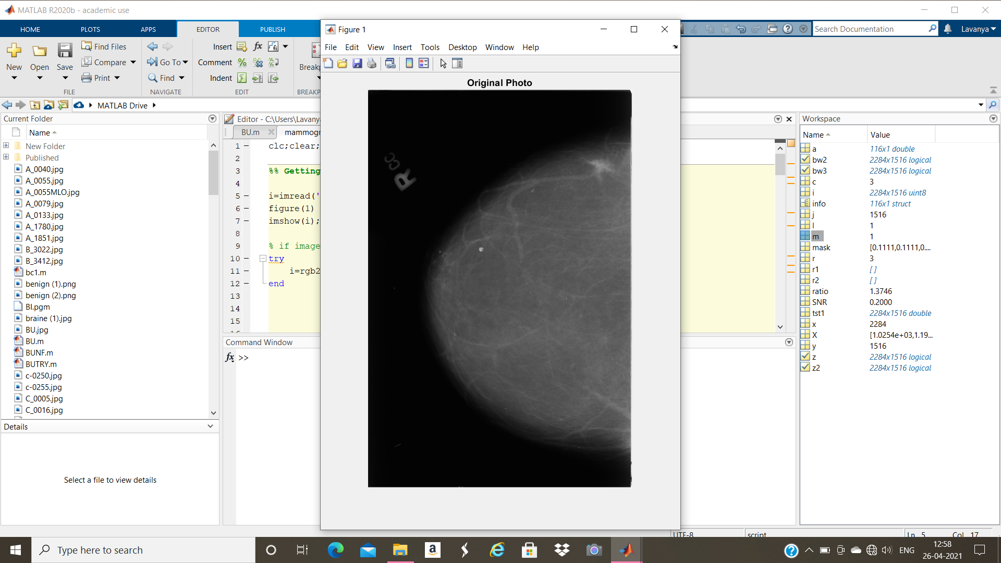

ORIGINAL IMAGE

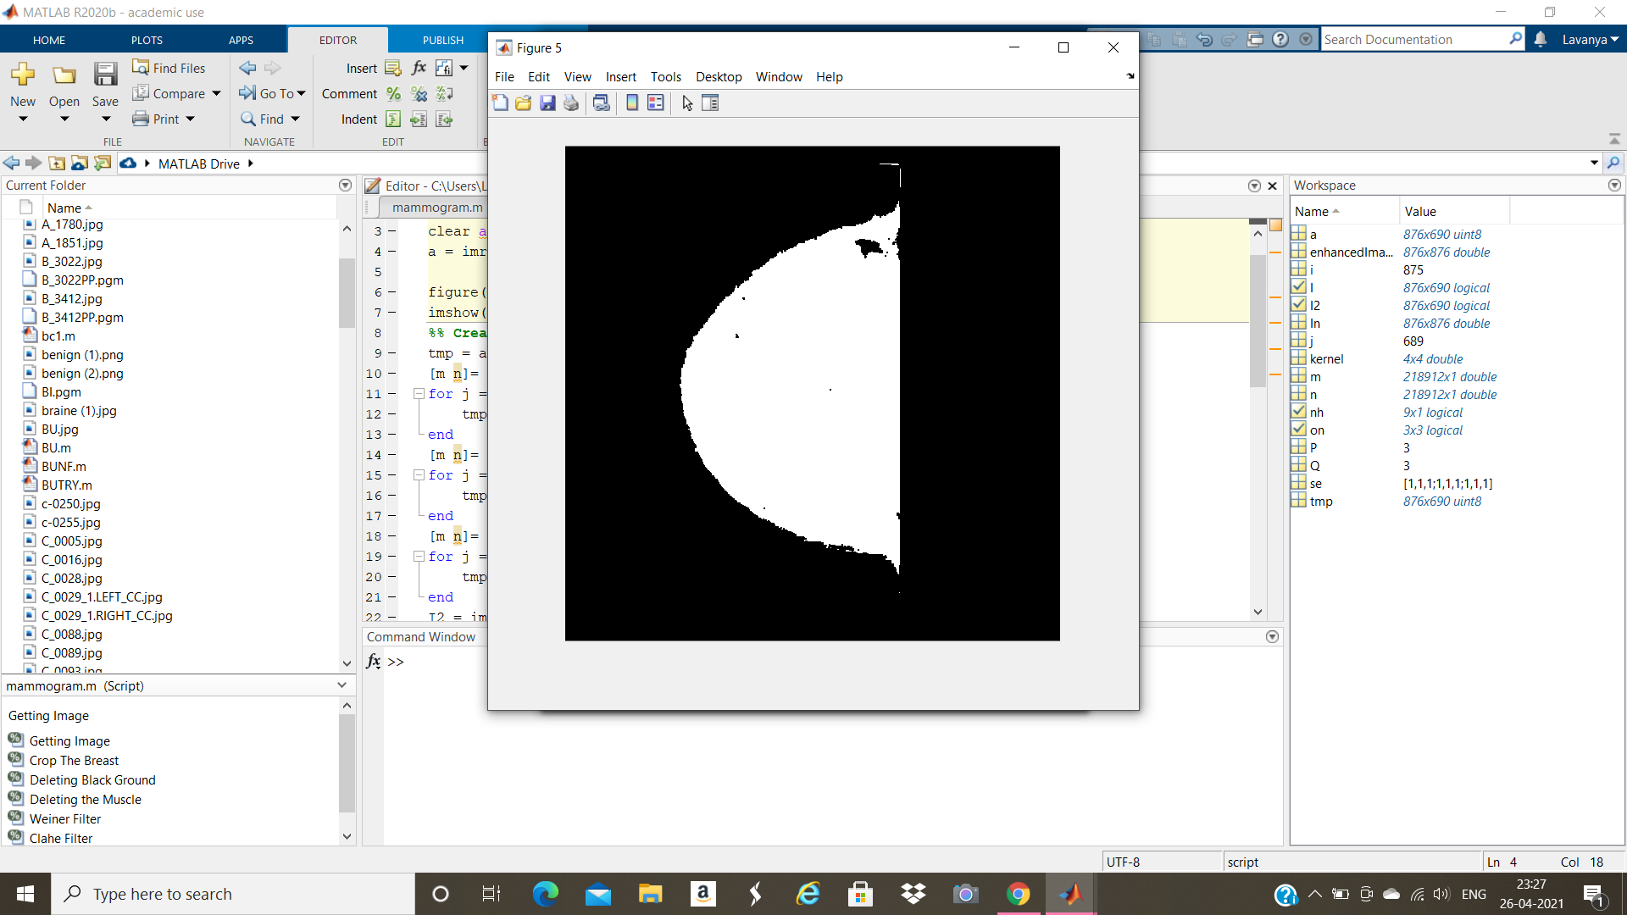

ROI EXTRACTED IMAGE

* In this case the average overlapping ratio was found to be 0.8250. So we conclude that among those four methods of region of interest extraction morphological operators show better ratios than other methods. For more better results we can integrate the morphological operators with thresholding methods.